**INFORMATICS INSTITUTE OF TECHNOLOGY**

**In Collaboration with ROBERT GORDON UNIVERSITY**

**ABERDEEN**

**Course: Artificial Intelligence and Data Science**

**Module Leader: Mohamed Ayoob**

**CM2606: Data Engineering**

**Assignment Type: Individual**

**Student Name: W.A.C.I.V Bandara**

**IIT ID – 20222453**

**RGU ID – 2311689**

Table of content

Introduction ##

In this coursework include analysis and prediction of HCHO gas distribution across the various districts in Sri Lanka using provided data. Three datasets given in the starting point of the coursework that including data of different districts. For further analysis I used a Sri Lankan weather dataset which include different attributes such as wind direction, elevation, temperature to make a deep analysis and finally made a timeseries forecasting for gas distribution in upcoming year and visualized predicted outputs using Power BI.

Dataset Selection

In the beginning of the coursework data set was given and it include information about HCHO distribution in Sri Lanka. For further analysis I used a data set from Kaggle.

Data Integration and Preprocessing part

For data cleaning and preprocessing part, I used pyspark. Using pyspark first I loaded given data sets separately and then cleaned and handled the missing values and did the preprocessing part separately and finally integrates those datasets and made a single data frame.

* Making a spark session to start the process

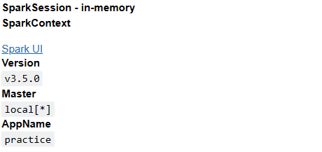

* Loading data frames and assigning column names for the data frame

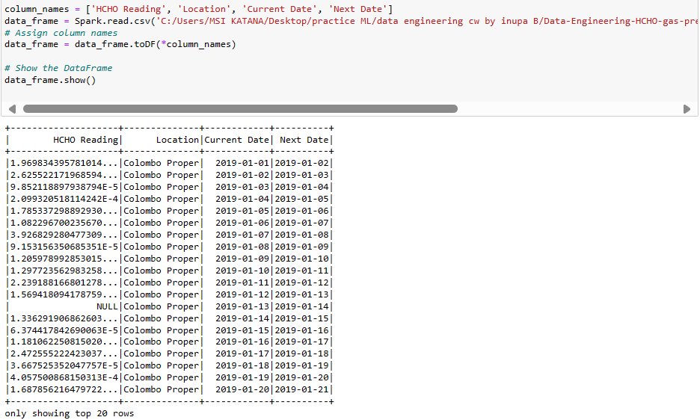

First, I assigned suitable column names and then assigned them to the data frame. Data is loaded from a csv file.

* Checking data types of each attribute

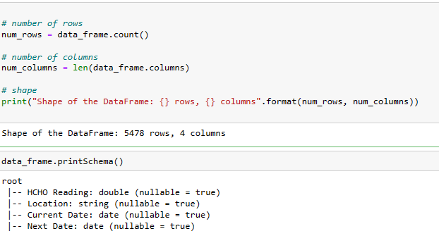

Checked the shape and schema of each attribute.

* Calculating the amount of missing values

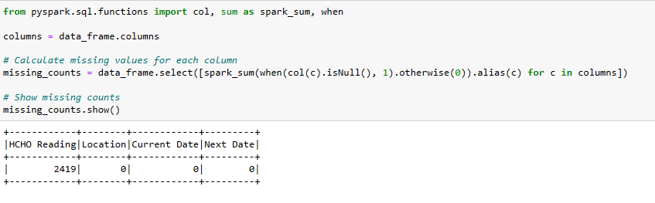

Calculated missing value count of each column using spark and taken it into a table.

Before handling missing values in HCHO Reading column I extracted that column separately and converted it into a pandas data frame and visualized the distribution of data because data distribution is an important factor when taking decisions in handling missing values.

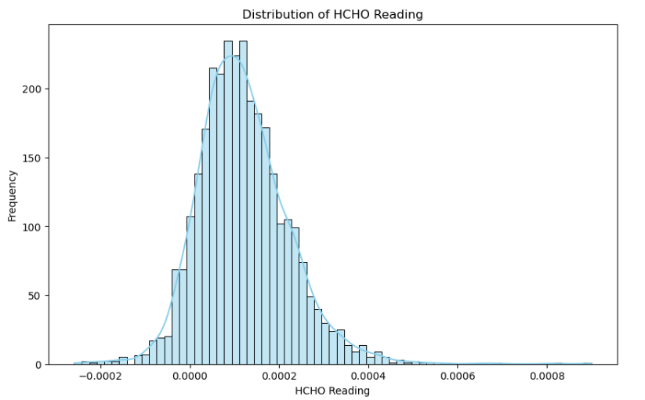

After confirming that the data is distribution following a normal distribution I decided to use forward windowspec and backward windowspec methods to fill the missing values.

* Confirmed no missing values.

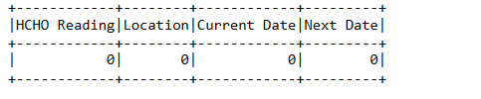

* Data distribution of the data frame after handling missing values.

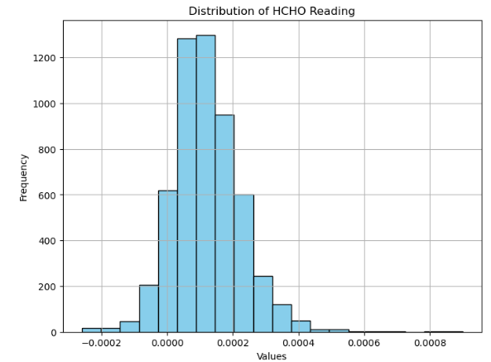

No considerable deviation in the distribution after handling missing values.

After handling missing values, I converted the full data frame into a pandas data frame to continue further inspection because we cannot do visualizations using pyspark.

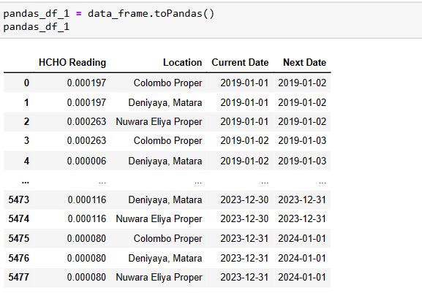

In the pandas data frame first selected the “HCHO Reading” column and then visualized outliers and calculated the number of outliers. For calculating outliers I used interquartile range method that used in boxplots and the logic used for calculating non outlier range is given below.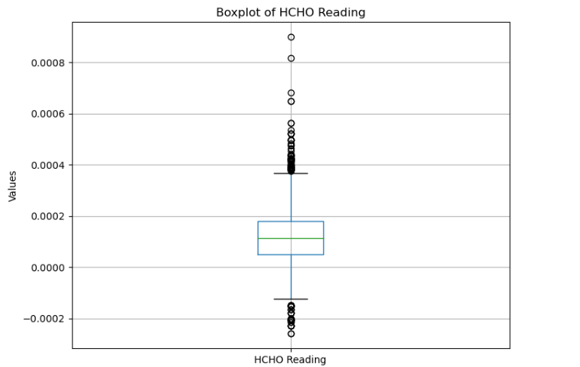

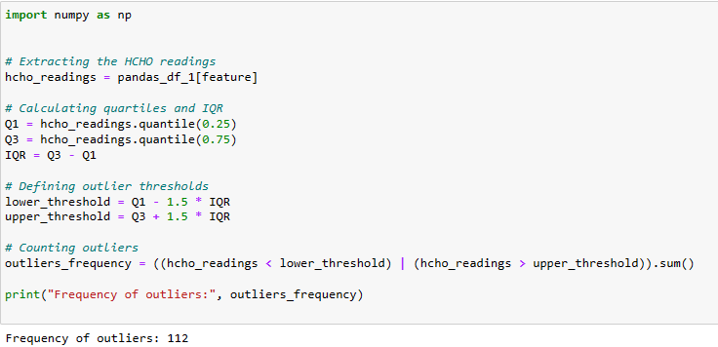

Since the number of outliers are very smaller when comparing with the original size of the data set, I decided to use winsorization method to winsorize outliers to upper and lower boundaries.

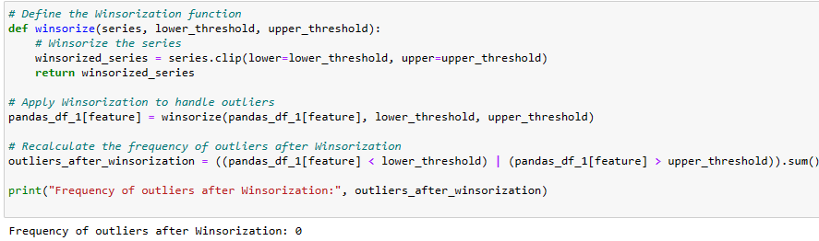

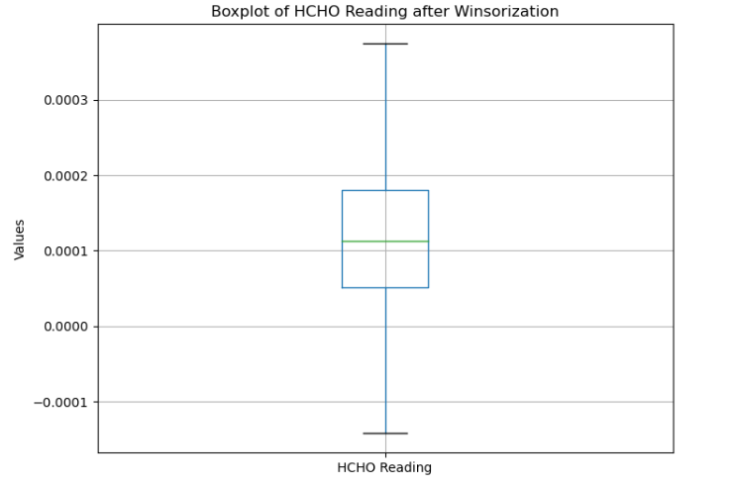

Removed the “Proper” part that include in several districts and converted it into the normal format. In this scenario I decided that we can identify each district. For an example we cannot identify proper difference between “Colombo” and “Colombo Proper”.

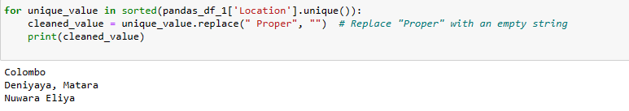

* After handling missing values, I did a manual inspection and checked other columns are in a proper format

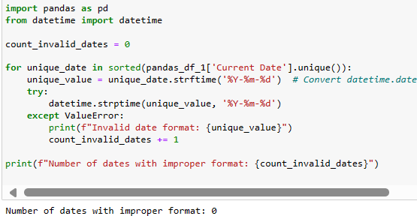

Then saved the data frame for use in future.

* Continued the above process of preprocessing in a same manner to other datasets and saved the datasets to use in future.

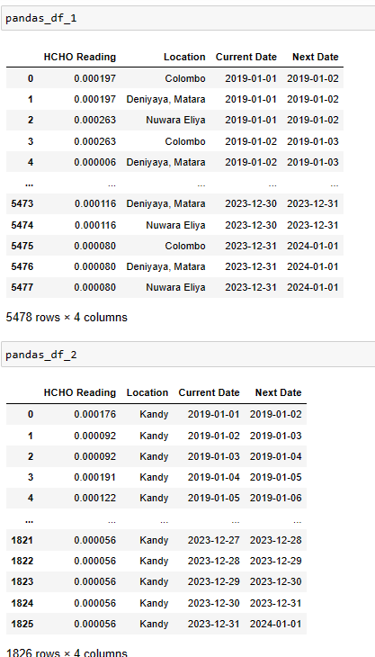

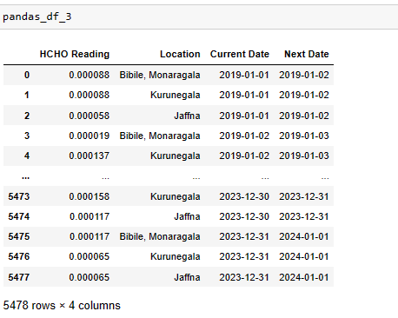

After preprocessing each data set individually, I concatenated all datasets in row wise and then made the final dataset for my analysis.

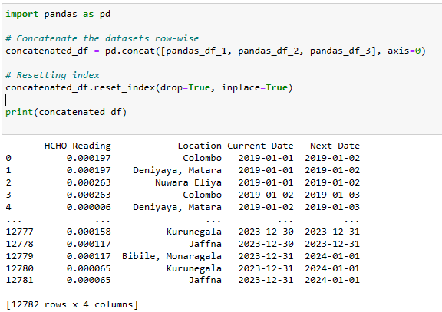

* Checking missing value in concatenated data frame

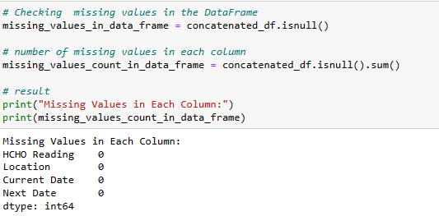

After concatenating the final dataset, again checked for missing values and confirmed that the preprocessing part is done without any error and no missing values in the final data frame.

Next checked and dropped duplicated values in concatenated data frame.

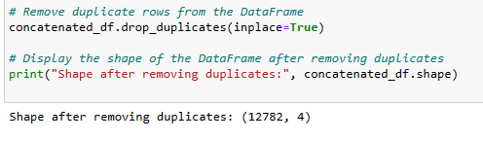

Then checked about the data types in the final data frame after concatenation.

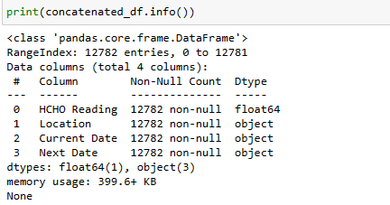

Taking the statistical summary of concatenated data frame

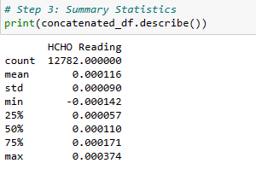

## concatenated data analytics ##

In the concatenated data frame most important attribute is “HCHO Reading” and in that attribute first I visualized the distribution of HCHO reading for an inspection and it follows a normal distribution and it is a good sign of data is distributed in a proper manner.

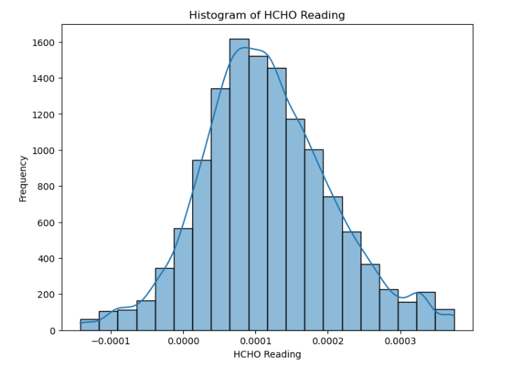

In the final dataset the “HCHO Reading” attribute follows a normal distribution. This distribution confirmed that the data related to this column distributed in a proper way. This is a good sign when taking decisions related to data and handling data

visualization with the count vs city.

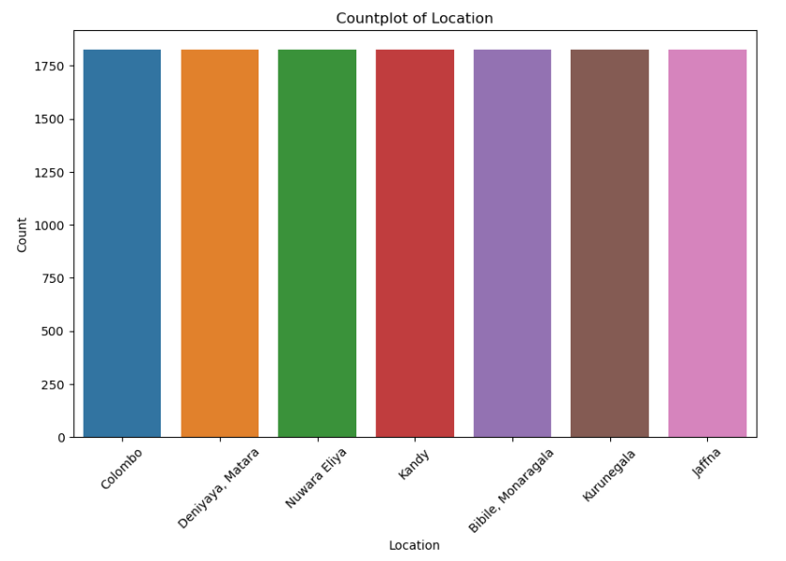

This bar graph displays the count of records related to each city in the data set. From this we can identify similar amount of records are allocated to each city. This is a good sign when training the model.

* “HCHO Reading” in location wise and taken a detailed statistical distribution

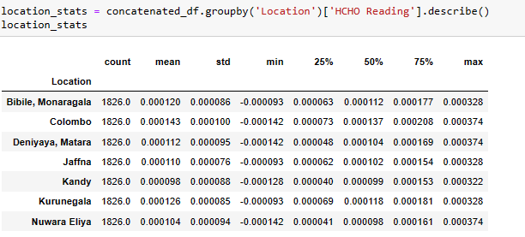

This table describe in detail statistical description of HCHO Reading in each city.

**########### Spatial Temporal analysis #############**

For the analysis of the data I started with analysis of seasonal data.

* Seasonal analysis

For the analysis purpose used “groupby” function for grouping data by year and month to continue the seasonal analysis.



* Then analyzed seasonal variations in HCHO levels with the months in each year.

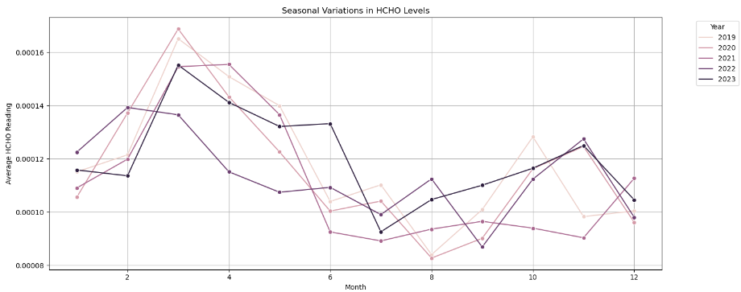

As a country that closer to the equator, Sri Lanka did not show noticeable seasonal changes such as winter, summer, spring, autumn but there are some seasonal changes that we can notice in each year during some seasons. In Sri Lanka first few 3 – 4 months are dry season for most of the part of the country and in that season, temperature is also higher than other seasons. In our analysis HCHO reading is little high in that season. After April we can notice two monsoon seasons in the country and in that period rainfall is changing and other factors such as wind speed also may affect for gas distribution.

* Analyzed average HCHO Reading and trend with the time

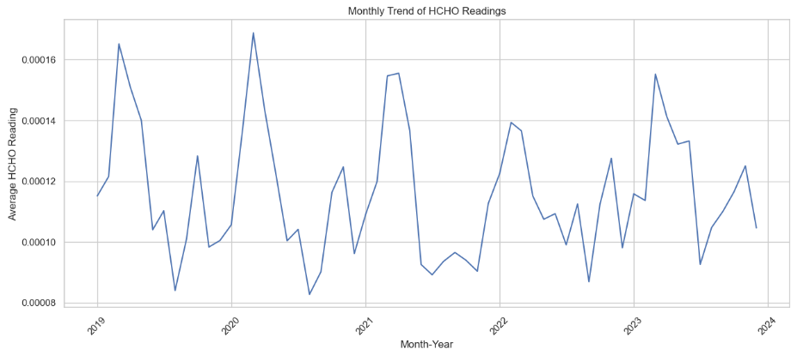

For these first aggregated HCHO readings in a monthly basis and taken the mean of the distribution and after that monthly data is used to plot the trend from 2019 to 2023. In the above graph we can identify a trend in first few months of the year.

* analysis of trend, seasonality and residual component.

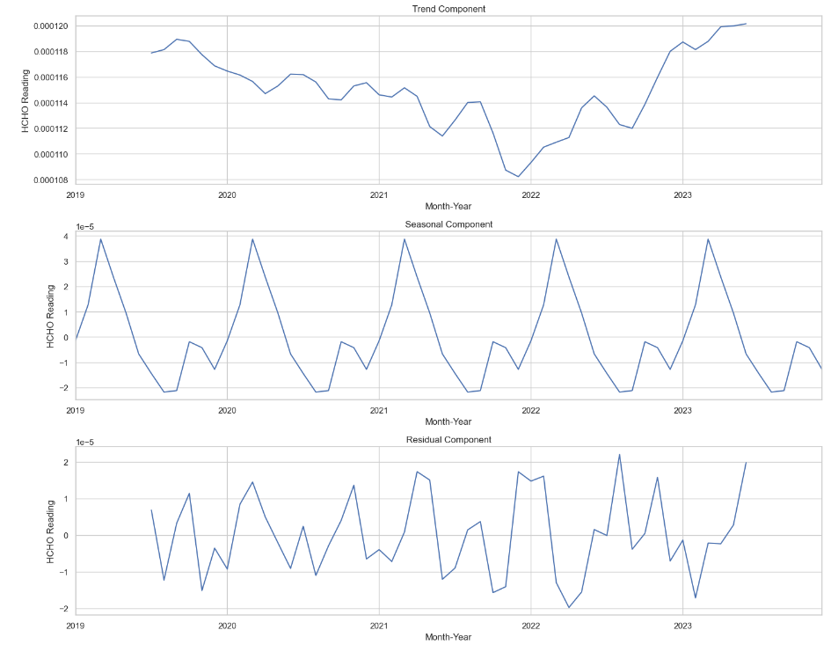

From the above analysis trend component is changing in a different way. Form 2019 to end of 2021 it decreases gradually and after 2022 middle season it stated increasing step by step. Covid lockdown period, economic situation of the country and electricity problem that made a direct impact on industries and that may be the reason for this.

In the seasonality component it shows a clear seasonality from 2019 to 2024 across the dataset.

For the residual component, there is a changing movement in that also.

* Grouped data with the location and visualized the average HCHO distribution by location

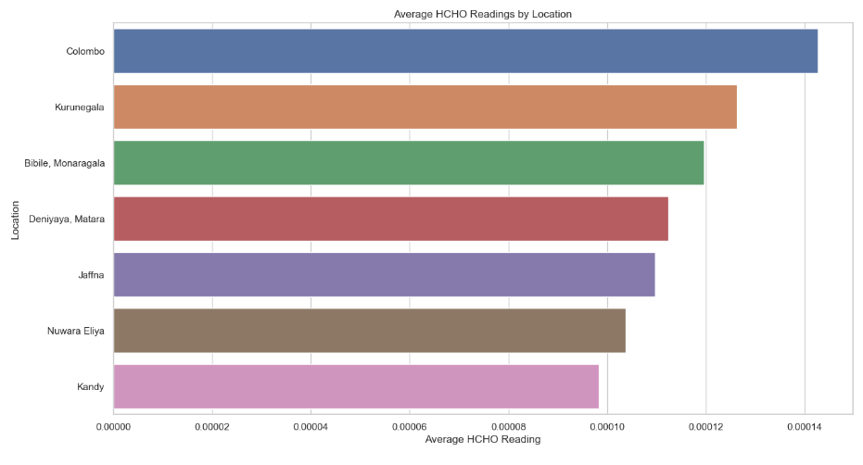

This visualization describes about change of average HCHO reading in each city. Colombo is the region that has maximum average distribution and it is the commercial capital of the country and Colombo has many industries and that also may be a reason for this distribution. Kurunegala takes the second highest distribution. Kurunegala belongs to north western province of Sri Lanka which main contributor for the paddy harvest and coconut cultivation in large scale. Kurunegala there are lot of farm lands and when using chemicals for harvesting activities and other reasons paddy fields emit different gases to the atmosphere such as methane, HCHO and other gasses. Other than that, Bibile, Monaragala, Matara, Deniyaya are famous for rubber, tea, and many other cultivations and some industries also in those regions agriculture may be the main reason for emission of toxic gasses. In Jaffna also there are some cultivations and Jaffna is closer to south India which produce large scale toxic gases and that may be a reason for increasing level of HCHO gas in Jaffna. Other than that Jaffna maintains high temperature and that also indirectly impactful for distribution of the gasses.

Nuwara Eliya and Kandy are popular for tea cultivation and that may be the reason for spreading HCHO in those hill country regions and also there are some industries like tea factories as well they also make an impact on this.

* plotted long term average HCHO levels with the time.

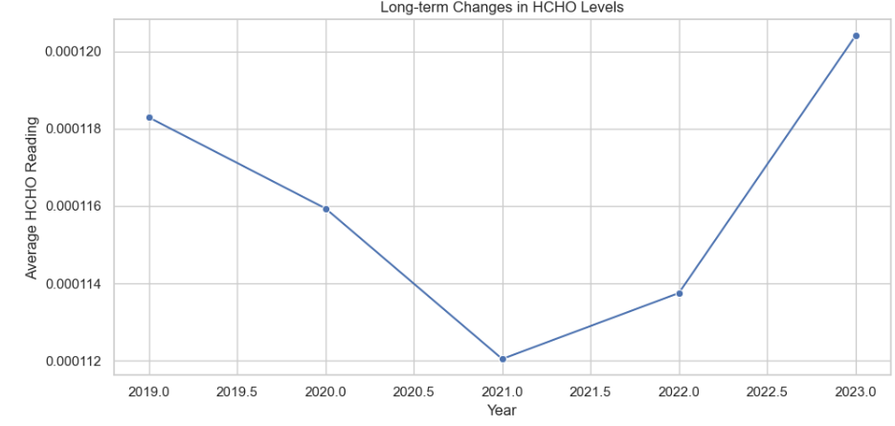

This indicate an average long term HCHO distribution in all cities form 2019 to end of 2023. In this analysis we can clearly identify a decreasing movement from 2019 to 2021 and increasing movement from 2021 to 2023. In 2021 period gas distribution decreases in an unprecedented proportion and Covid pandemic and lockdown period and financial situation of the country may be the major reasons for this. After lockdown period we can identify a clear deviation of gas distribution and In beginning of the 2023 gas distribution is in the highest point and the after pandemic new normal situation of the country may be the reason for this.

* plotted monthly changes of average HCHO levels. For this I used two different ways.

1. Plotting data in separate diagrams to analysis with respect to each city.

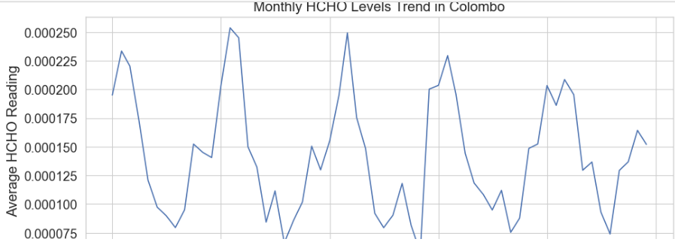

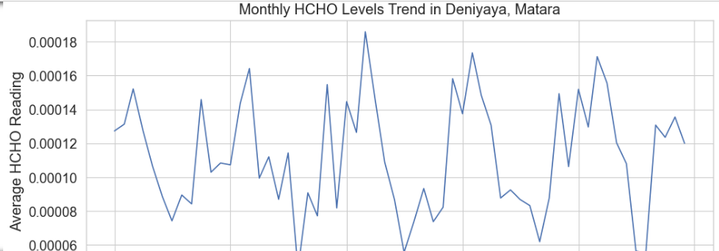

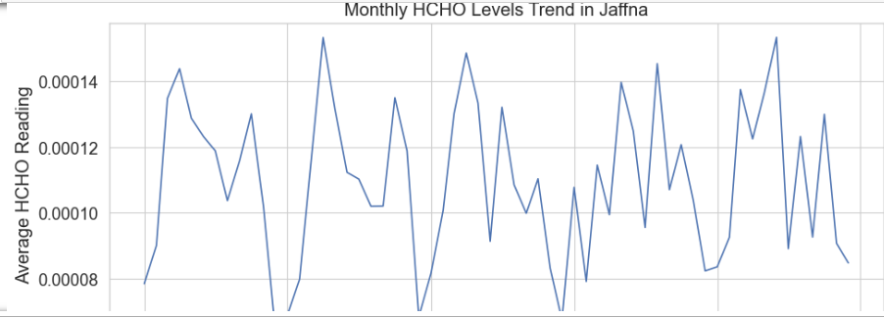

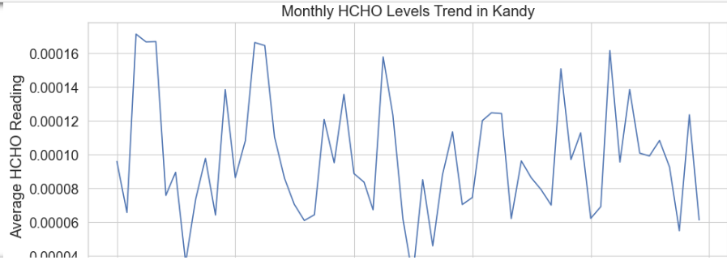

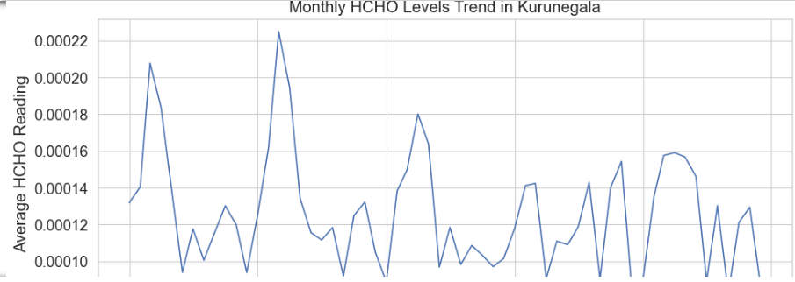

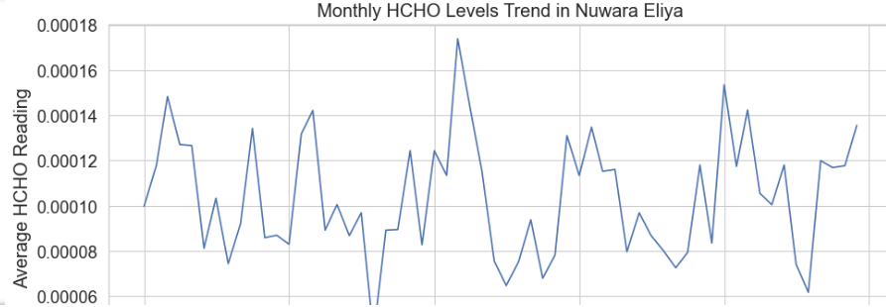

In above visualizations we can see the average distribution of HCHO gas in each city in a different angle and combination of many factors affected for this distributions such as geographical location of the city, economic situation in the country, covid lockdown and many more reasons.

1. Plotted all in one diagram to analyze it city wise.

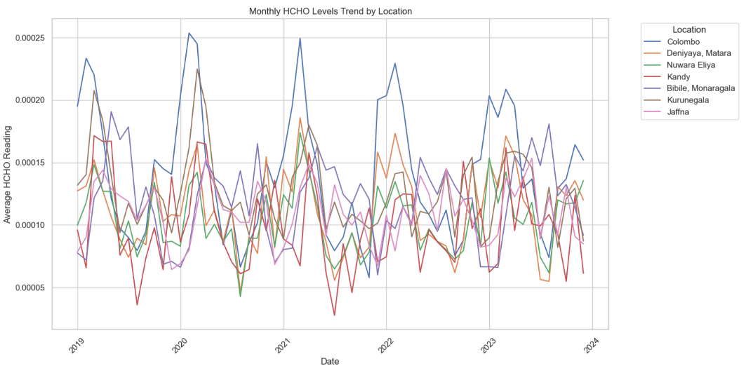

* Analyzed the distribution of HCHO gas variation in each city in lockdown period. In this situation I assumed that lockdown period is from 2020-03-01 to 2021-10-01 due to various situations in the country.

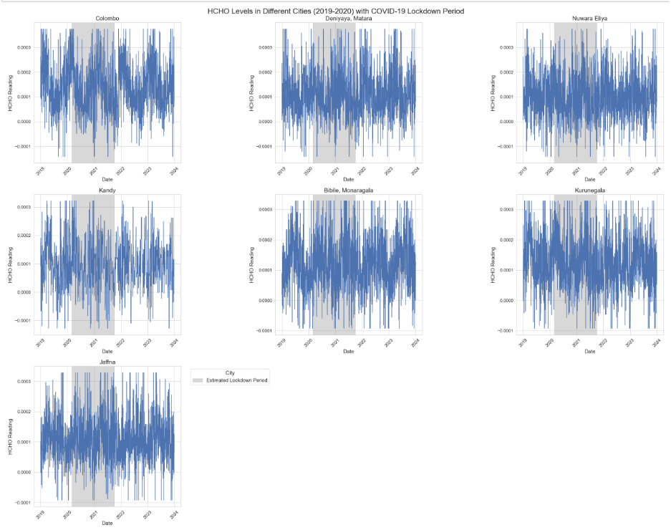

In most of cities there is a clear downfall of HCHO emission in this lockdown period but in Jaffna we cannot identify such situation.

* Then taken the average HCHO level of each city before, after and during lockdown period.

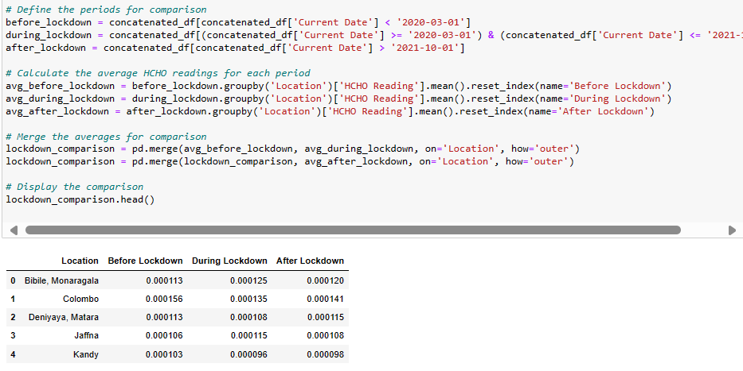

According to data in Sri Lanka I assumed that covid lockdown season extends from 2020 / 03 / 01 to 2021 / 10 / 01 and in this period Sri Lanka faced for 3 main lockdowns and many other restricted seasons.

* Taken the HCHO levels and how they effect for human. **# reference**
* safe level to prevent irritation for most people: 0.00008 mol/m²
* caution level where discomfort and irritation can begin: 0.0001 mol/m²
* high concern level indicating significant risk of respiratory issues: 0.0003 mol/m²
* dangerous level, potentially lethal or causing severe health effects: 0.01 mol/m²

using this I visualized how gas levels varies in different cities using periods such as before, during and after lockdown using folium heatmaps.

Logic used for making the heatmap

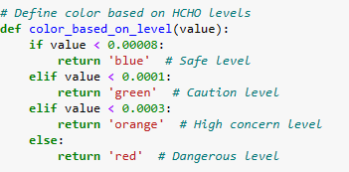

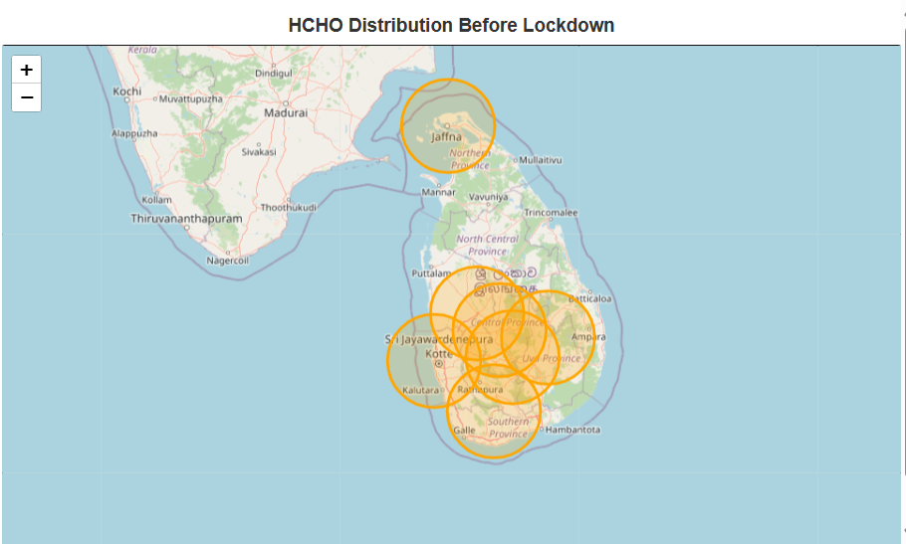

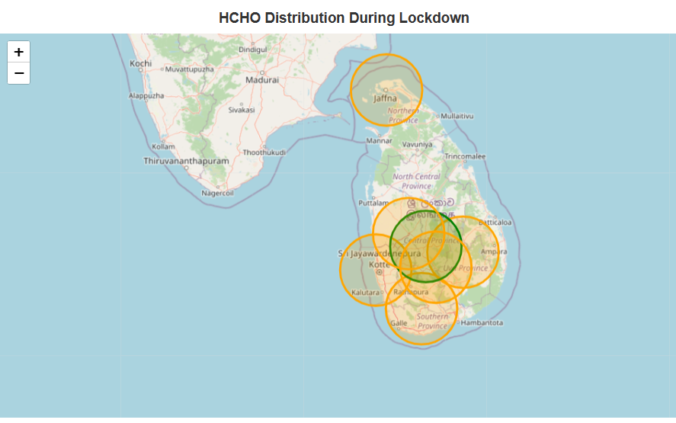

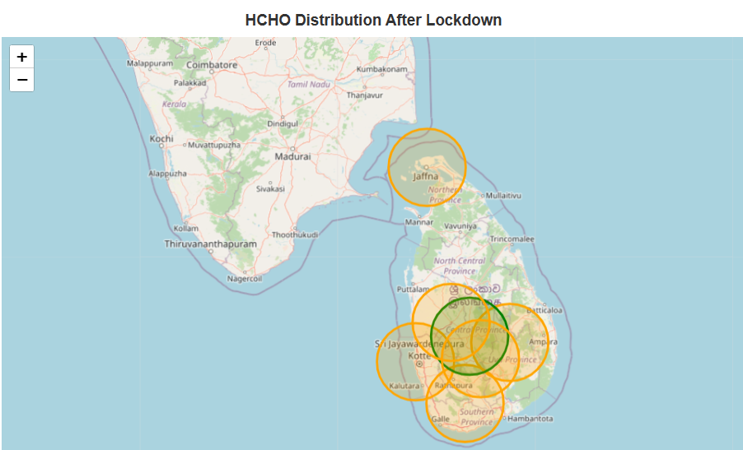

* Taken the average HCHO gas distribution with in above 3 seasons.

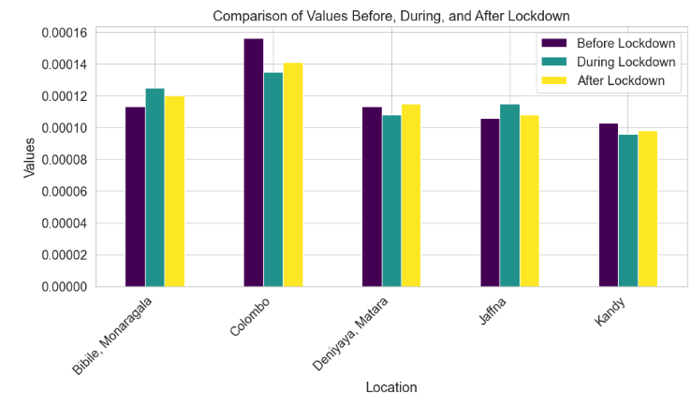

**Further extra analysis**

For further analysis used a Sri Lankan weather dataset separately and preprocessed that dataset separately and loaded in this notebook for continue advanced analysis using main factors that contributing for distribution of a gas.

That dataset is a cleaned dataset but it has details belongs to following cities.

'Colombo’, ‘Kandy’, ‘Jaffna’, ‘Matara’, ‘Kurunegala'.

* Then merged my concatenated dataset with my new weather dataset using date and location.

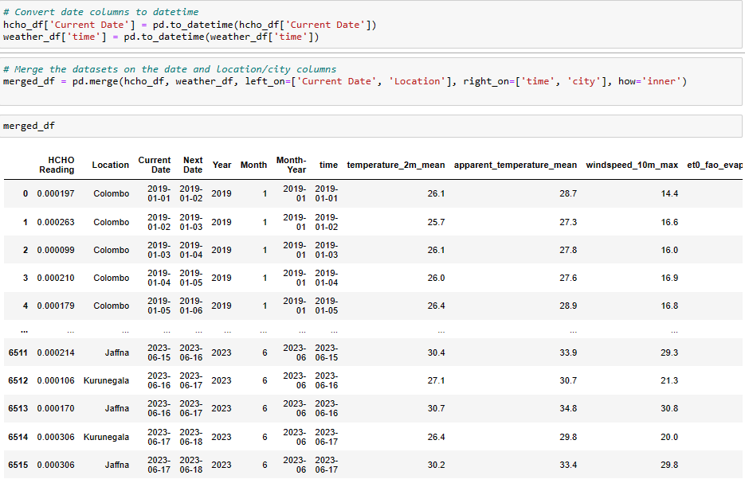

* Checking for merging errors

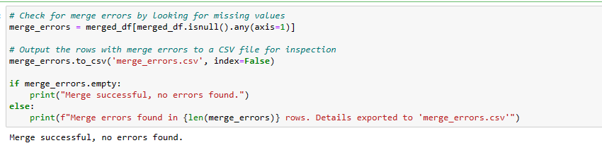

* Checking duplicates and missing values and dropping those values from the new dataset.

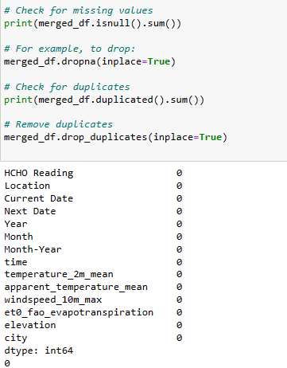

* Saving the final dataset for further analysis.

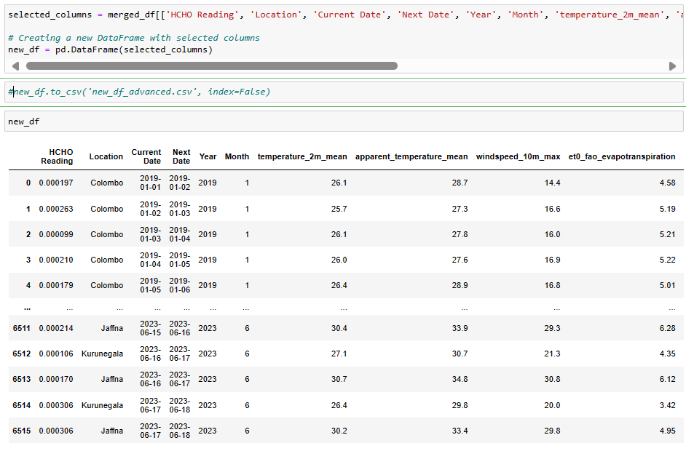

* First, analyzed HCHO distribution over months.

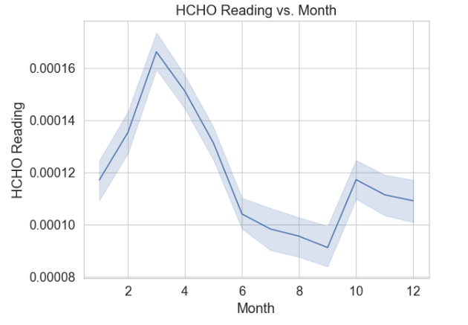

This analysis is done using the previous original data frame with all cities and this also following a close distribution.

* HCHO distribution vs mean temperature and temperature ranges.

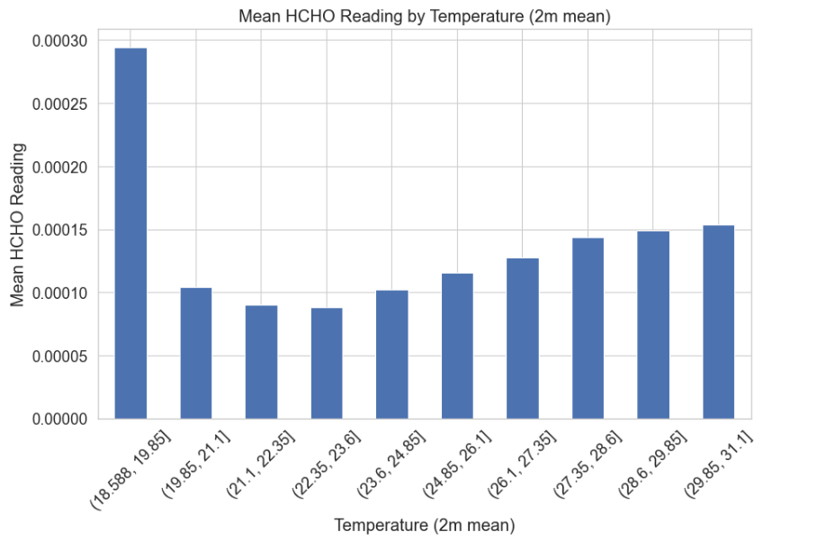

Temperature is a main factor that affect for a distribution of a gas. In this chart less ranges affect mostly for higher distribution of the gas and average temperature levels affect for less distribution and again high temperature levels affect for more distribution. In this graph we can say that in less temperatures and high temperatures spread of gas is high.

* HCHO distribution vs apparent temperature and temperature ranges.

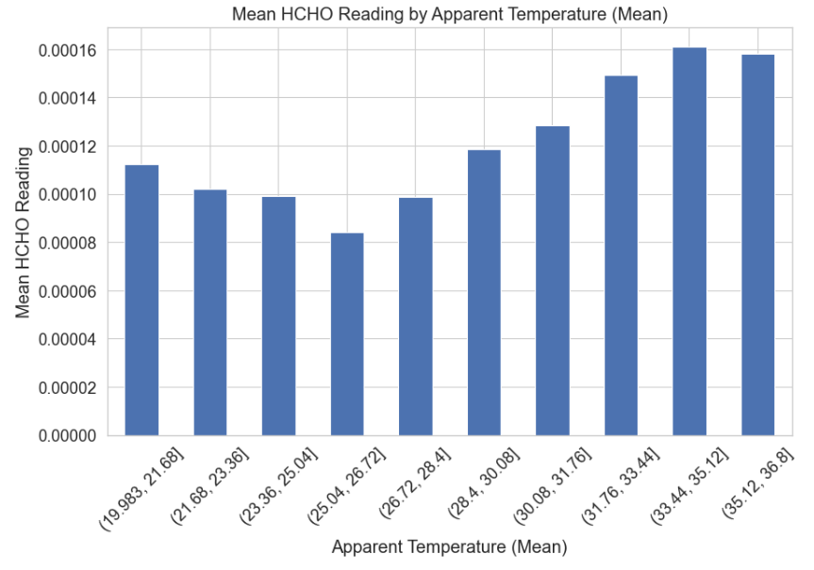

When considering about the apparent mean of the temperatures vs mean HCHO reading we can identify some opposite insights because in this, when temperature is increasing the gas distribution is more increasing. However, this graph follows a main feature of last distribution which is high distribution in low and high temperatures and low distribution in mid temperatures.

* HCHO distribution vs Max windspeed.

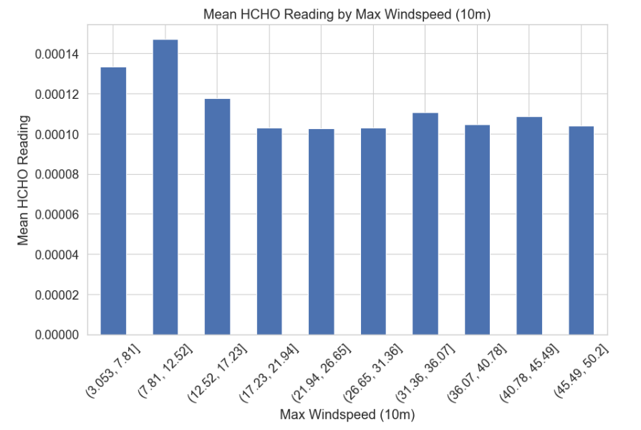

Wind speed plays an important role in distribution of gasses. When we analyze the above bar chart we can identify that low speeds affects for high distribution of the gas and when the speed of the wind gradually increasing the distribution of the gas did not show more deviations and it remains same.

* HCHO distribution vs Evaporation

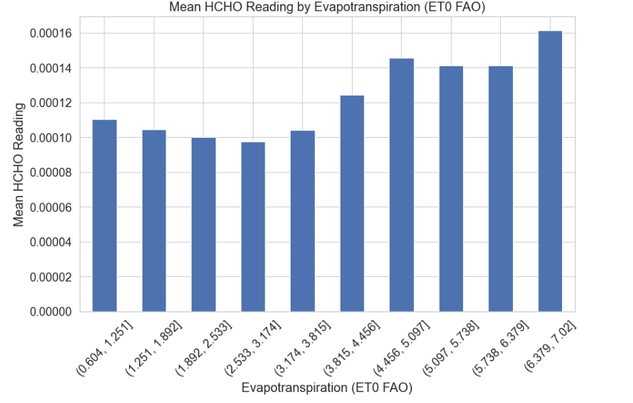

Above bar chart describes HCHO gas distribution with evaporation. When analyzing this gas distribution is quite low in low and moderate evaporation levels and when evaporation level is high gas distribution is also increasing.

* HCHO distribution vs Elevation

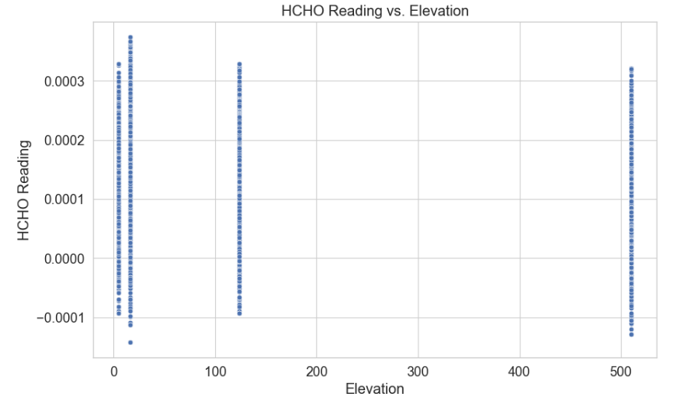

In this analysis we cannot identify clear insights with the elevation.

* Shortwave radiation sum vs HCHO Reading

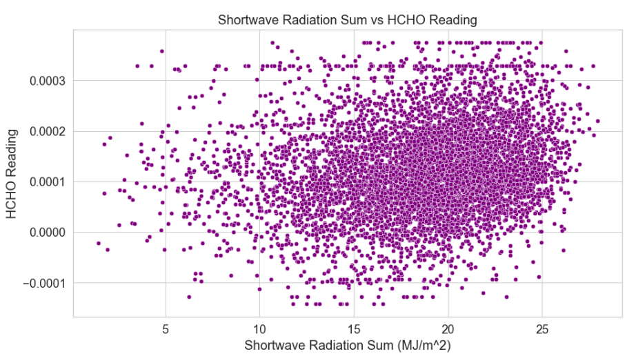

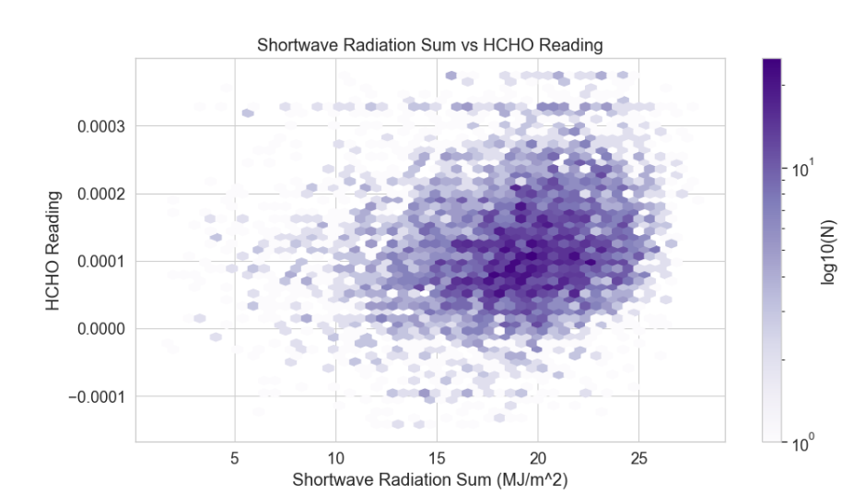

Above plots describes the changes of HCHO readings with the changes of shortwave radiation in two different ways. HCHO distribution is quite low in low radiation levels such as 5, 10. When radiation level increasing, we can have more HCHO readings. Most occurrences are in 15, 20 radiation range and 0.0001 – 0.0002 range. However, HCHO readings are high when radiation is high.

* Rain sum vs HCHO Reading

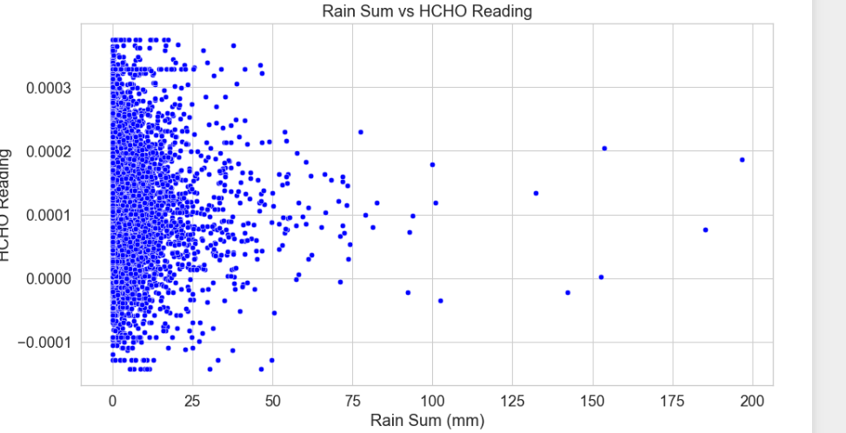

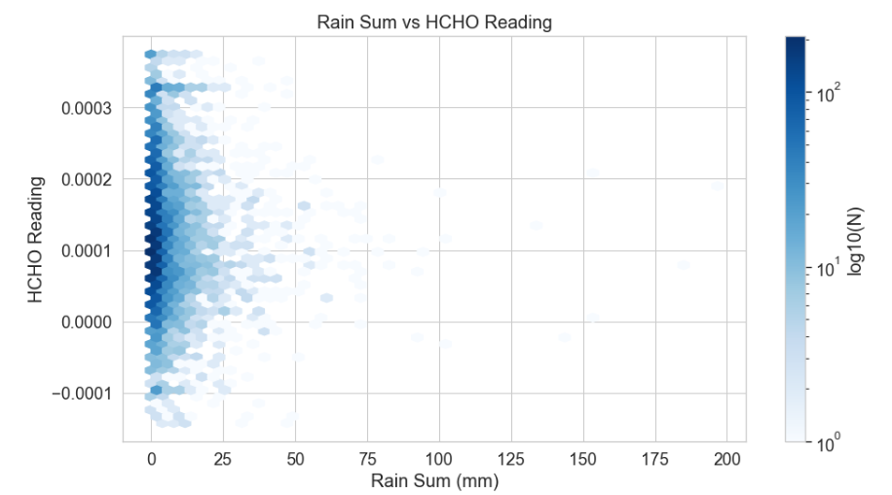

In this analysis we can analyze distribution of sum of the rain fall with HCHO reading. In this visualization we can understand that most of readings are good in less rainfalls. When there is no rainfall, we can say that HCHO distribution is high or moderate.

* Precipitation hours vs HCHO Reading

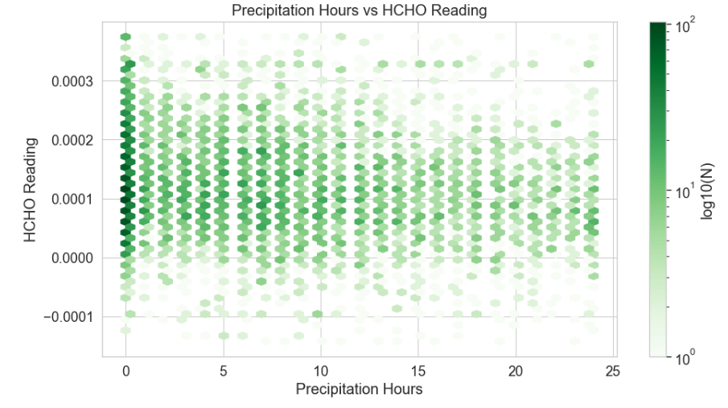

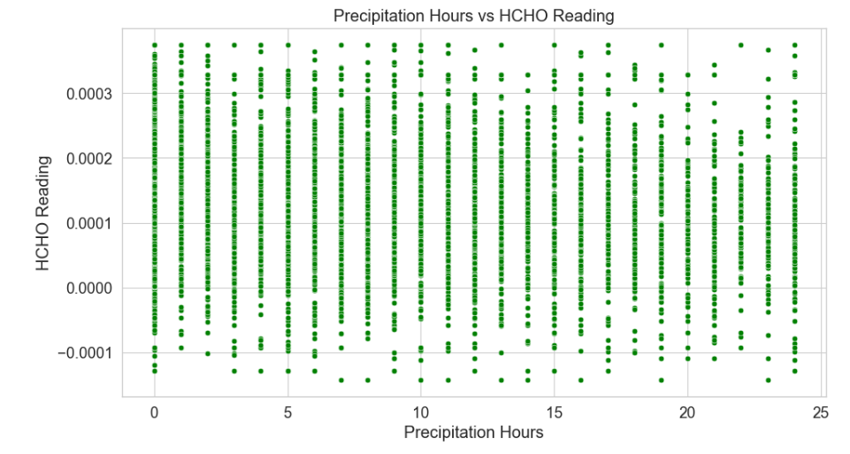

Above analysis explains about the HCHO reading with precipitation hours. In this we cannot make a clearer decision but we can say that when there are less hours of precipitation readings are quite high and moderate. However, rainfall makes less impact for the gas distribution.